I. Installation

Table of Contents
Installation 2
The “General” tab 2
The “F-Keys” tab 4
The “Accounts” tab 5
The “Forms” tab 7

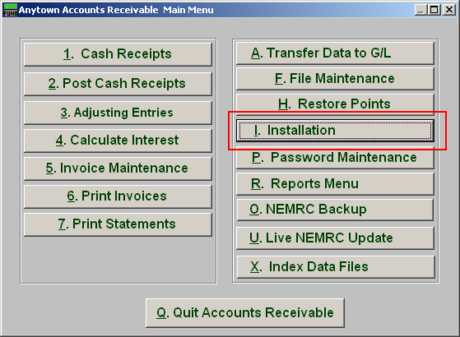
Click on “I. Installation” from the Main Menu and the following window will appear:

Installation

The “General” tab

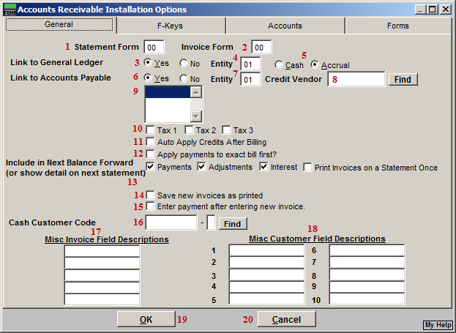
- Statement Form: This form can be designed under the forms tab. It is commonly created by NEMRC during installation and is custom per site.

- Invoice Form: This form can be designed under the forms tab. It is commonly created by NEMRC during installation and is custom per site.

- Link to General Ledger: Choose “Yes” to link to the NEMRC General Ledger.

- Entity: Enter the appropriate General Ledger Entity to link to when item 3 is answered “Yes.”

- Cash or Accrual: Select the method of reporting to the General Ledger when item 3 is answered “Yes.”

- Link to Accounts Payable: Choose “Yes” to link to the NEMRC Accounts Payable.

- Entity: Enter the appropriate Accounts Payable Entity to link to when item 6 is answered “Yes.”

- Credit Vendor: Enter the default Accounts Payable vendor number to transfer Accounts Receivable overpayments to.

- Select the default comment code for invoices/statements: Comments are defined in the Main Menu item “F. File Maintenance,” under the “Comment Maintenance” section. Selecting a comment code here will result in the message appearing on invoices and statements if designed into your form.

- Tax 1 OR Tax 2 OR Tax 3: The system will provide up to three different sales tax calculations. Check off as many as needed.

- Auto Apply Credits After Billing: Check this box to have credits automatically apply to open invoice amounts during the updating process that takes place after printing invoices.

- Apply payments to exact bill first? Check this box to have payments look for matching invoice billing amounts to apply payment before applying to the oldest invoice with a balance.

- Include in Next Balance Forward: Payments, Adjustments and Interest can be set to directly post to a customer balance and the General Ledger by checking them off here. When any item is not checked off it will appear on the next statement/invoice print in detail and can be updated after that particular print routine is completed.

- Save new Invoices as printed: Check this option to eliminate the need to print invoices in order to process payments. This may be used by some users of this application who process invoices as a record of billing and payment after the fact.

- Enter payment after entering new invoice: Check this option to eliminate the need to exit and process payments from the menu and directly go to that process. This works in conjunction with item 14. This may be used by some users of this application may process invoices as a record of billing and payment after the fact.

- Cash Customer Code: Enter the customer number assigned in “F. File Maintenance” that represents a non-invoice customer. This is used when processing through the Yard Screen at a transfer station.

- Misc Invoice Field Descriptions: You can define up to five miscellaneous pieces of information to track here. During invoice entry these descriptions will appear for data entry on the Miscellaneous Tab.

- Misc Customer Field Descriptions: You can define up to ten miscellaneous pieces of information to track here. These descriptions will appear in the Main Menu item “File Maintenance,” under “Customer Maintenance” on the Miscellaneous tab.

- Okay: Click this button to save the changes and return to the previous screen.

- Cancel: Click “Cancel” to cancel and return to the previous screen.

The “F-Keys” tab

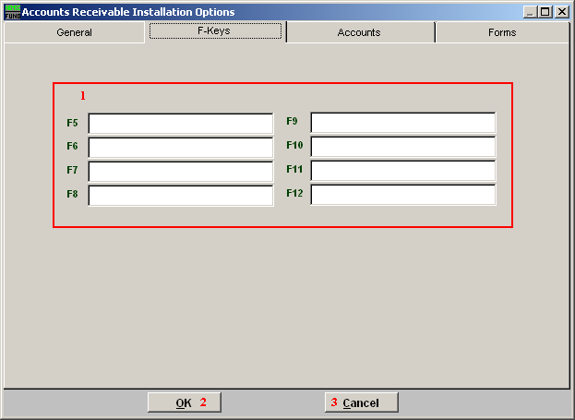
Each of the F Key fields (F5-F12) is linked to the associated F-Key on your keyboard. In other words, when you hit the “F_” key on your keyboard, the text entered for that F-Key will appear.

- F Keys: Type in the command for each “F_” key.

- OK: Click this button to except and save.

- Cancel: Click “Cancel” to cancel and return to the previous screen.

The “Accounts” tab

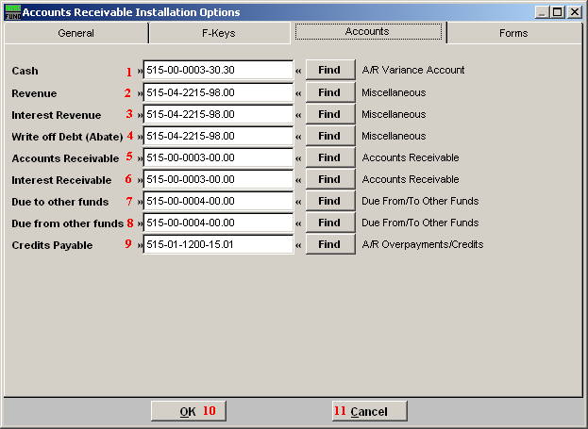
These accounts are only used for default values during Code set up.

- Cash: Enter the chart of accounts number or click on “Find” and select from there.

- Revenue: Enter the chart of accounts number or click on “Find” and select from there.

- Interest Revenue: Enter the chart of accounts number or click on “Find” and select from there.

- Write off Debt (Abate): Enter the chart of accounts number or click on “Find” and select from there.

- Accounts Receivable: Enter in the chart of accounts number or click on “Find” and select from there.

- Interest Receivable: Enter the chart of accounts number or click on “Find” and select from there.

- Due to other funds: Enter the chart of accounts number or click on “Find” and select from there.

- Due from other funds: Enter the chart of accounts number or click on “Find” and select from there.

- Credits Payable: Enter the chart of accounts number of click on “Find” and select from there.

- OK: Click this button to save the changes and return to the previous screen.

- Cancel: Click “Cancel” to cancel and return to the previous screen.

The “Forms” tab

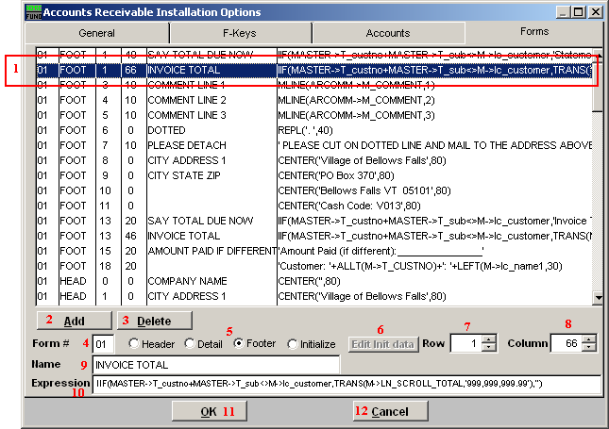
- Form description by line item: Select the line detail of the form you wish to edit. The items are modified using items 4 through 10 below.

- Add: Click this button to add a line description.

- Delete: Click on a line above you wish to remove then click this button to delete the line.

- Form #: The form number must be consistent for use under the “General” tab.

- Header OR Detail OR Footer OR Initialize: The location on the form must be either “FOOT” (bottom), “HEAD” (top) or “SCRL” (detail lines). The Initialize value defines the locations to start each section.

- Edit Init data: Select the line that indicates “INT” for the form from the detail lines in item 1 then click the button to change the default form initialization values.

- Row: This represents the line number within item 5 on which to print.

- Column: This represents the column position on item 7 to start printing at.

- Name: This describes what is to be printed for the user.

- Expression: This is a Foxpro Expression used to define what form the program to print.

- OK: Click this button to save the changes and return to the previous screen.

- Cancel: Click “Cancel” to cancel and return to the previous screen.

